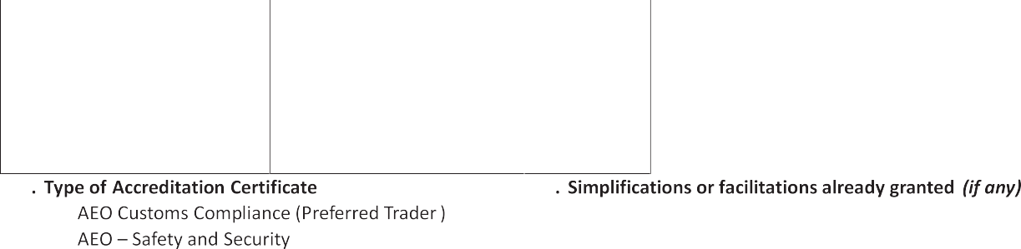

Explanatory notes:

- Applicant: Enter the full name of the company / economic operator.
- Taxpayer Identification Number: Enter the TIN as issued upon registration with ERS.

- Legal status: Enter the legal status as mentioned in the document of establishment.

- Date of establishment: Enter the day, month and year of establishment.
- Address of establishment: Enter the full address of the place where your entity was established, including the country.

- Location of main place of business: Enter the full address of the place of your business where the main activities are carried out.
- Website: enter website of your company

- Contact person: Indicate the full name, phone and fax numbers, and e-mail address of the contact person designated by you within your company to be contacted by the customs authorities when examining the application.

- Correspondence address: Fill in only in case it differs from your address of establishment.

- Legal registration numbers: The registration number issued by the company registration Ministry / administration in Eswatini.

- Management of Customs Clearances: Indicate whether the company self- manages Customs clearances through an employee (i e. clearance is done in-house) or it uses a clearing agent for its customs declarations and if in-house, provide names of personnel responsible for customs clearance.

- Employee name and position of the person responsible for in- house clearances or where customs clearing is outsourced provide the name and contact details of the clearing agent.

- Type of accreditation certificate: Mark in the relevant box. AEO — Customs Compliance is equivalent to the Preferred Trader Program. (NB. Currently the ERS is implementing only the Customs Compliance accreditation program, AEO — Safety and Security is not yet operational)

- Simplifications or facilitations already granted: Indicate the type of simplification / facilitative procedures already granted. Please include the relevant customs procedure/ the accreditation number.

- Name, date and signature of the applicant:

  - Signature: the signatory should add his capacity. The signatory should always be the person who represents the applicant as a whole.
  - Name: name of the applicant and the stamp of the applicant.
  - Date: the date on which the application is signed and submitted for consideration to ERS
  - Number of annexes: the applicant shall give the following general information:
    - Appendix 1 - Organizational chart of the Company
    - Appendix 2 - List of executive management and board members, stating names, roles, addresses and passport number.
    - Appendix 3 - List of principle shareholders / owners including percentage of shareholding / ownership and stating names, addresses and passport number.

Page 2 of 2

